## Structure of Power System /Typical AC Transmission System

The electrical energy is produced at generating stations, and through the transmission network, it is transmitted to the consumers by distribution. Between the generating stations and the distribution stations, three different levels of voltage are used.

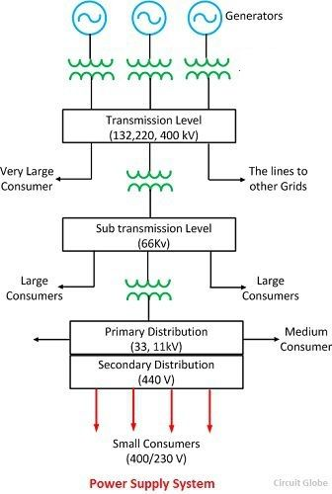

**Generation System**: Electric power is commonly (or usually) generated at 11 kV in generating stations. While in some cases, generation voltage might be higher or lower. Generating machines, to be used in power stations, are available between 6 kV to 25 kV. Generation voltage is less than transmission voltage due to insulation problem in generator winding.

**Transmission System**: Generating voltage is then stepped up to 132kV, 220kV, 400kV is called transmission system. Stepping up the voltage level depends upon the distance at which power is to be transmitted. Longer the distance, higher will be the voltage level. Stepping up of voltage is to reduce the power loss i.e. I2R losses in transmittingthepower (when voltage is stepped up, the current reduces by a relative amount so that the power remains constant, and hence I2R loss also reduces). This stage is called as primary transmission.

The voltage is the stepped down at a receiving station to 33kV or 66kV. Secondary transmission lines emerge from this receiving station to connect substations located near load centers (cities etc.).

**Distribution System**: Voltage is stepped down again to 11kV at a substation. Large industrial consumers can be supplied at 11kV directly from these substations. Also, feeders emerge from these substations. This stage is called as [primarydistribution](https://www.electricaleasy.com/2018/01/electric-power-distribution-system.html).

Also, the voltage is stepped down to 400V for commercial large consumers through three phase supply or 230V to local household consumers are called secondary distribution system.

# Comparision of types of sources

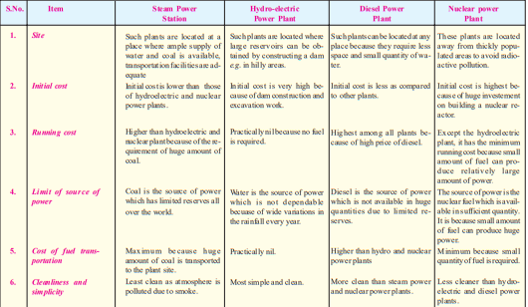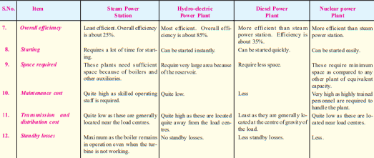

# Variable Load on Power Station

The load on a power station varies from time to time due to uncertain demands of the consumers and is known as variable load on the station. A power station is designed to meet the load requirements of the consumers.

The consumers require their small or large block of power in accordance with the demands of their activities. Thus the load demand of one consumer at any time may be different from that of the other consumer. The result is that load on the power station varies from time to time.

Effects of variable load

The variable load on a power station introduces many perplexities in its operation. Some of the important effects of variable load on a power station are:

1. Need of additional equipment
2. Increase in production cost

## Load Curve and Load Duration Curve

Load curve is the variation of load with time on a Power Station. As the load on a Power Station never remain constant rather it varies time to time, these variations in load is plotted on half hourly or hourly basis for the whole day. The curve thus obtained is known as Daily Load Curve.

Therefore, by having a look at the Load Curve, we can check the peak load on a Power Station and its variation. From the figure below, it is quite clear that the peak load (6 MW) on a particular Power Station is at 6 P.M.

[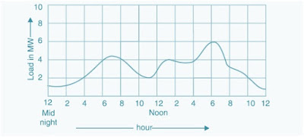](https://3.bp.blogspot.com/-jA2m0E7Ys2E/V5wOeyzVrNI/AAAAAAAABqs/gVgcBM-NqfAKP2pGilc88wo36DQirhA2QCK4B/s1600/Load+Curve.jpg)

The monthly load curve can be plotted using the daily load curve for a particular month. For this purpose the average load for different time for the whole month is calculated and the value thus obtained is plotted against time to get the Monthly Load Curve. Monthly Load Curve is used to fix the rate of energy.

In the same manner Yearly Load Curve can be obtained using the 12 monthly load curves. The Yearly Load Curve is used for calculation the Annual Load Factor.

### Importance of Load Curve:

* From the daily load curve we can have insight of load at different time for a day.
* The area under the daily load curve gives the total units of electric energy generated.

**Units Generated / day = Area under the daily Load Curve in kW**

* The peak point on the daily load curve gives the highest demand on the Power Station for that day.
* The average load per day on the Power Station can be calculated using the daily load curve.
* **Average load = Area under the daily Load Curve (kWh)/ 24 hrs.**
* Load curve helps in deciding the size and number of Generating Units.
* **Load Factor = Avg. Load / maximum Load =  Avg. Load x24 / 24xmaximum Load**

**= Area under daily Load Curve/Area of Rectangle having Daily Load Curve**

* Load curve helps in the preparing the operation schedule of the generating units.

### **Load Duration Curve**:

Load Duration Curve is the plot of Load versus time duration for which that load was persisting. Load Duration Curve is obtained from the Daily Load Curve as shown in figure below.

[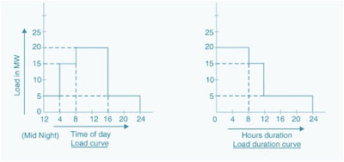](https://4.bp.blogspot.com/-aCcC5RuIRoQ/V5wOjuurT2I/AAAAAAAABq0/Um6Ily3ogEo3z7Q2HJDpcJevUbQ2JtRygCK4B/s1600/Load+duration+curve.jpg)

From the above Load Duration Curve, it is clear that 20 MW of Load is persisting for a period of 8 hours, 15 MW of Load for 4 hours and so on.

It is also quite clear that, the area under the load duration curve is equal to the daily load curve and gives the number of units (kWh) generated for a given day. The load duration curve can be extended for any period of time i.e. it can be drawn for a month or for year too.

In this curve, the load elements of a load curve are arranged in order of descending magnitudes. So, the area under the load duration curve and the area under the load curve are equal but the ordinates are arranged in the order of descending magnitudes.  In other words, the maximum load is represented to the left and decreasing loads are represented to the right in the descending order.

## Mass Curve

* A mass curve is a plot between the cumulative volume of water that can be stored from stream flow and the time in day, weeks or in months.
* Such a plot helps in designing the size of the storage required for hydro-electric power plants. Also, with the help of mass curves it is possible to predict the maximum possible uniform flow for a given storage capacity and the periods of low stream flows.
* The mass curve can be expressed mathematically as :

Where, V = Volume of run off Discharge in m/s. A typical mass curve is shown in Figure A. It gives following information:

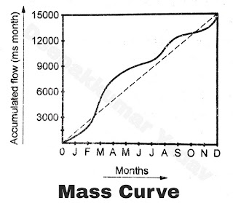

The slope of curve at any point indicates the rate of flow of water at any point of time. If the curve is steep, it shows high flow rate of water, if horizontal then flow rate of water is zero. If the curve is concave it shows that period of dry days i.e. in flow of water is less than evaporation.

• A small storage is used to meet the fluctuating demand for small
period (one day). When powerhouse is away from the main... Mass curve
 

Mass curves of water utilization & monthly inflow
  Software for Duration curves calculations
• A tool from the older generation that allows calculating and rendering
of dura...

### **Demand Factor in power system**:

[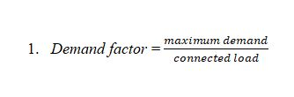](https://www.eeejobbd.com/wp-content/uploads/2019/08/demand-2Bfactor.jpg)

The demand factor is the ratio of the maximum demand on a power station to the connected load. Maximum demand is the highest demand for loads during a period. The maximum demand needs to determine the installed capacity of a power plant.

Connected load is the sum of the ratings of all equipment connected to the power station. The connected load must be greater than the maximum demand. Therefore, the demand factor is always less than 1.

### **Load Factor in power system**:

[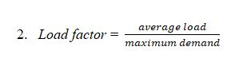](https://www.eeejobbd.com/wp-content/uploads/2019/08/load-2Bfactor.jpg)

The load factor is the ratio of the average load to the maximum demand during a period. The average load is the average of different loads during a period. The load factor is always less than 1 because the average load is less than the maximum demand.

The lesser the maximum demand the higher is the load factor. If the load factor is higher on a power station, the cost per unit generated will be lesser.

Demand factor

It is the ratio of maximum demand on the power station to its connected load i.e.,

Demand factor = $\frac{Maximum demand}{Connected load}$

The value of demand factor is usually less than 1. It is expected because maximum demand on the power station is generally less than the connected load. If the maximum demand on the power station is 80 MW and the connected load is 100 MW, then demand factor = 80/100 = 0·8. The knowledge of demand factor is vital in determining the capacity of the plant equipment.

### **Diversity factor in power system**:

[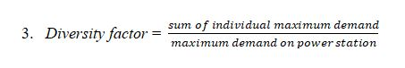](https://www.eeejobbd.com/wp-content/uploads/2019/08/diversity-2Bfactor.jpg)

The diversity factor is the ratio of the sum of individual maximum demands of the consumers to the maximum demand on the power station. The diversity factor will be greater than 1.

The higher the diversity factor the lesser is the cost of generation of power on a power plant and also the lesser is the maximum demand on the power station. Hence the capital investment on the plant is reduced and less space is required.

* The reciprocal of diversity factor is coincidence factor
* The coincidence factor is the ratio of the maximum demand of a system, or part under consideration, to the sum of the  individual maximum demands of the subdivisions

**Note**:

* There is generally confusion between Demand factor and Diversity factor. **Demand factors should be ideally applied to individual loads and diversity factor to a group of loads.**
* When you talk about ‘diversity’, there are naturally more than one or many loads involved.
* Demand factor can be applied to calculate the size of the sub-main, which is feeding a Sub panel or a fixed load like a motor etc, individual Load.
* Demand factors are more conservative and are used by NEC for service and feeder sizing.
* If the Sub panel have total load is 250 kVA, considering a Demand factor of 0.8, we can size the feeder cable for 250 x 0.8= 200 kVA.
* The Diversity Factor is applied to each group of loads (e.g. being supplied from a distribution or sub-distribution board), size the Transformer.

### **Plant Capacity Factor in power system**:

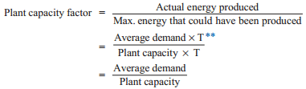

Plant capacity factor is the ratio of the average demand for the plant capacity.

Annual plant capacity factor = $\frac{(annual kWh output)}{(plant capacity*8760)}$

The plant capacity factor is an indication of the reserve capacity of the plant. A power station is so designed that it has some reserve capacity for meeting the increased load demand in future. Therefore, the installed capacity of the plant is always somewhat greater than the maximum demand on the plant. So, A power plant should have reserve capacity fed to the additional load demand.

Plant capacity = reserve capacity + maximum demand

It is interesting to note that difference between load factor and plant capacity factor is an indication of reserve capacity. If the maximum demand on the plant is equal to the plant capacity, then load factor and plant capacity factor will have the same value. In such a case, the plant will have no reserve capacity.

### **Plant Use Factor in power system**:

[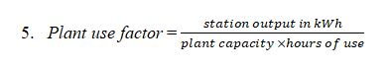](https://www.eeejobbd.com/wp-content/uploads/2019/08/plant-2Buse-2Bfactor.jpg)

[Plant use factor](http://www.uomisan.edu.iq/eng/ar/admin/pdf/73130411002.pdf) is the ratio of kWh generated to the product of plant capacity and the number of hours for which the plant was in operation.

* Units generated per annum = average load in kW * hours in a year

Average load = maximum demand * load factor (L.F.)

## Plant Utilization factor in power system

https://latex.codecogs.com/gif.latex?%5Cfn_jvn%206.%20Plant%20%5C%20Utilization%20%5C%20Factor%20%3D%20%5Cfrac%7BMaximum%20%5C%20Demand%7D%7BPlant%20%5C%20Capacity%7D

**Units Generated per Annum**

It is often required to find the kWh generated per annum from maximum demand and load factor.

The procedure is as follows:

Load factor = $\frac{Average load}{Max. demand}$

∴ Average load = Max. Demand × L.F.

Units generated/annum = Average load (in kW) × Hours in a year

= Max. Demand (in kW) × L.F. × 8760

## ****Significance of Load Factor****

Load factor basically gives an idea of cost of per unit power generation. How?

As Load Factor = Average Load / Maximum Demand

We can write it for a period of T hrs as below,

Load Factor = Average Load xT / Maximum Demand xT

                    = Units generated in T hrs / Maximum Demand xT

Thus a higher value of load factor means, less maximum demand. Less maximum demand can be catered by a low capacity power plant. As the capacity of plant is less, this means the initial as well as running cost will be low. Thus the cost per unit power generation will be less.

Again, in other sense higher value of load factor means higher Average Load. This means the plant is operating near its rated capacity. Therefore the cost of per unit power generation will be less

* Higher value of load factor means lower will be cost per unit generated and vice versa it is desirable that the value of load factor always higher.
* Higher the load factor means lower maximum demand or higher average demand ( or higher number of unit generation for a given time )
* As tariff charges depends upon fixed part-maximum demand and variable part number of units consumption.
* Lower value maximum demand, resulting lower fixed charges of tariff which is distributed among large number of units generated therefore overall cost per unit generation is reduced.
* As the number of unit generation for a given time increases, load factor also increases.
* Greater number of unit generation for a given plant, means cost per unit decreases.

## Importance of diversity factor

* Lower the value of maximum demand, higher the diversity factor as vice versa.
* The capital cost of power station depends upon capacity of the power station.
* Lower the maximum demand, lower the capital required for the power station.
* For a given number of consumers, higher the diversity factor of load, smaller will be capacity of the plant therefore fixed charges for the plant will be reduced.
* Therefore, utility company always tries to increases load factor as well as diversity factor.

**Numerical**

